**Department of Electrical Engineering**

|  |  |
| --- | --- |
| **Faculty Member: Sir Hassan Khaliq** | **Dated: 2/13/2023** |
| **Semester: 6th** | **Section: C** |

EE-357 Computer and Communication Networks

Experiment – 1

**Introduction to Hub, Switch and Router**

|  |  |  |  |  |  |  |
| --- | --- | --- | --- | --- | --- | --- |
|  |  | **PLO5/**  **CLO3** | | **PLO5/**  **CLO3** | **PLO5/**  **CLO3** | **PLO5/**  **CLO3** |
| **Name** | **Reg. No** | **Viva / Quiz / Lab Performance** | **Analysis of data in Lab Report** | **Modern Tool Usage** | **Ethics and Safety** | **Individual and Team Work** |
|  |  | **5 Marks** | **5 Marks** | **5 Marks** | **5 Marks** | **5 Marks** |
| **Muhammad Ahmed Mohisn** | **333060** |  |  |  |  |  |
| **Imran Haider** | **332569** |  |  |  |  |  |
| **Amina Bashir** | **343489** |  |  |  |  |  |
|  |  |  |  |  |  |  |

Contents

2 EXPERIMENT 2

2.1 PART – 1 2

3 Objective 2

4 Resources Required 2

5 Introduction 2

5.1 Hub 2

5.2 Switch 3

5.2.1 Switch: 2950-24 3

5.2.2 Switch: 2950T-24 3

5.2.3 Switch: 2960-24TT 3

5.2.4 Switch: Switch –PT 4

5.2.5 Switch: 3560-24PS 5

5.3 Router 5

6 Procedure 6

6.1 output 7

6.2 Output: 8

6.3 Switch Output 8

1 Objective 10

2 Resources Required 10

3 Introduction 10

4 Conclusion 22

# EXPERIMENT

## PART – 1

**Introduction to Hub, Switch and Router**

# Objective

This lab exercise is designed to understand the difference between Hub, Switch and Router.

# Resources Required

* Computer
* Packet Tracer (version 5 or higher)

# Introduction

Hubs, switches, and routers are all devices which let you connect one or more computers to other computers, networked devices, or to other networks. Each has two or more connectors called ports into which you plug in the cables to make the connection. Varying degrees of magic happen inside the device, and therein lies the difference. I often see the terms misused so let's clarify what each one really means.

## Hub

A hub is typically the least expensive, least intelligent, and least complicated of the three. Its job is very simple: anything that comes in one port is sent out to the others. That's it. Every computer connected to the hub "sees" everything that every other computer on the hub sees. The hub itself is blissfully ignorant of the data being transmitted. For years, simple hubs have been quick and easy ways to connect computers in small networks.

## Switch

A switch does essentially what a hub does but more efficiently. By paying attention to the traffic that comes across it, it can "learn" where particular addresses are. For example, if it sees traffic from machine A coming in on port 2, it now knows that machine A is connected to that port and that traffic to machine A needs to only be sent to that port and not any of the others. The net result of using a switch over a hub is that most of the network traffic only goes where it needs to rather than to every port. On busy networks this can make the network significantly faster.

### Switch: 2950-24



The Cisco Catalyst 2950-24 is a member of the Cisco Catalyst 2950 series switch family.  
It is a standalone, fixed-configuration, managed 10/100 switch providing user  
connectivity for small- to mid-sized networks.

It does not support add-in module

### Switch: 2950T-24



The Cisco Catalyst 2950T-24 is a member of the Catalyst 2950 Series Intelligent Ethernet  
Switch family. It is a fixed-configuration, standalone switch that provides wire-speed  
Fast Ethernet and Gigabit Ethernet connectivity for mid-sized networks.

It does not support add-in modules.

### Switch: 2960-24TT



The Cisco Catalyst 2960-24TT is a member of the Catalyst 2960 Series Intelligent  
Ethernet Switch family. It is a fixed-configuration, standalone switch that provides wirespeed Fast Ethernet and Gigabit Ethernet connectivity for mid-sized networks.

It does not support add-in modules.

### Switch: Switch –PT



The Switch-PT generic switch provides ten slots, one console port, and one auxiliary port.

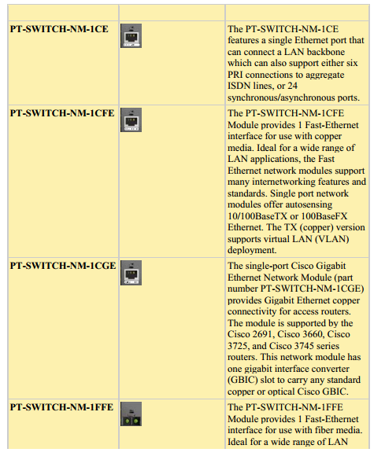

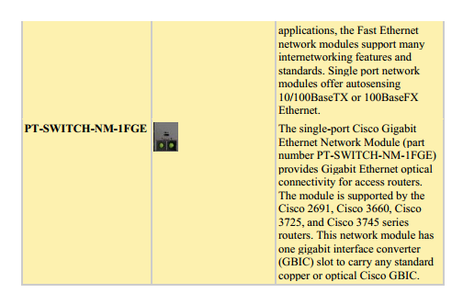

### Switch: 3560-24PS

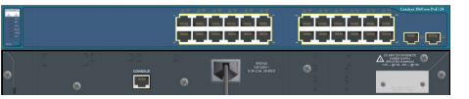

The Cisco Catalyst 3560-24PS is a member of the Catalyst 3560 Series Intelligent  
Ethernet Switch family. It is a fixed-configuration, standalone switch that provides wire speed Fast Ethernet and Gigabit Ethernet connectivity for mid-sized networks.

It does not support add-in modules.

## Router

A router is the smartest and most complicated of the bunch. Routers come in all shapes and sizes from the small four-port broadband routers that are very popular right now to the large industrial strength devices that drive the internet itself. A simple way to think of a router is as a computer that can be programmed to understand, possibly manipulate, and route the data its being asked to handle. For example, broadband routers include the ability to "hide" computers behind a type of firewall which involves slightly modifying the packets of network traffic as they traverse the device. All routers include some kind of user interface for configuring how the router will treat traffic. The really large routers include the equivalent of a full-blown programming language to describe how they should operate as well as the ability to communicate with other routers to describe or determine the best way to get network traffic from point A to point B.

# Procedure

1. Open Packet Tracer 5 from Desktop or Start Menu. The following window appears.

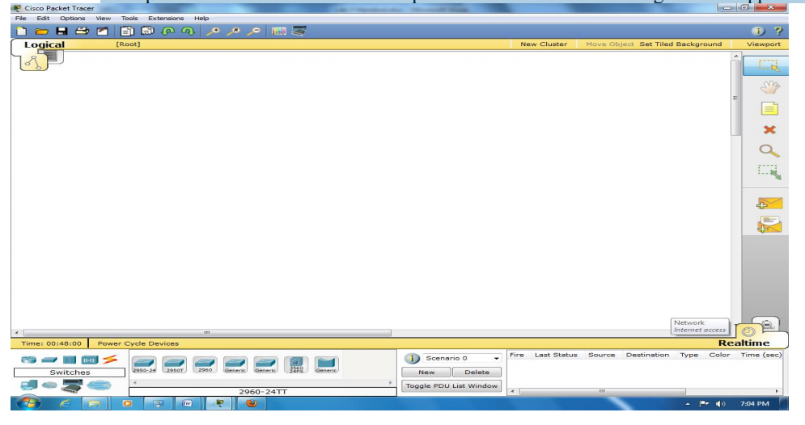

2. Click on **Hubs** in lower left part, click on **Hub-PT** and then again click in the main window. The Hub will appear in the main window.

3. Place Three PCs **Generic (in** **End Devices)** in the main window.

4. Find suitable connections in **Connections** to have the following topology.

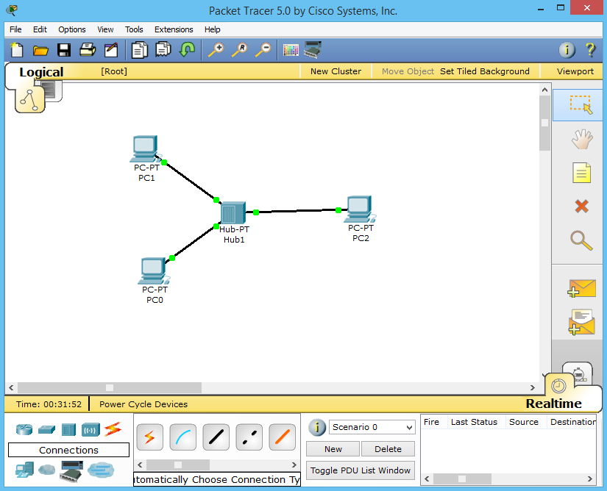

5. Double-click on PC0 and goto **Dektop** tab. Click on **IP Configuration** and enter  
**192.168.1.2** as the IP address and **255.255.255.0** as subnet mask. **192.168.1.3** for PC1. Enter any IP address for PC3 and PC4 (in same network).

6. To check communication, goto **Desktop** tab of any PC, click on the **Command**  
**Prompt** and use any networking command (ping,tracert etc).

## output

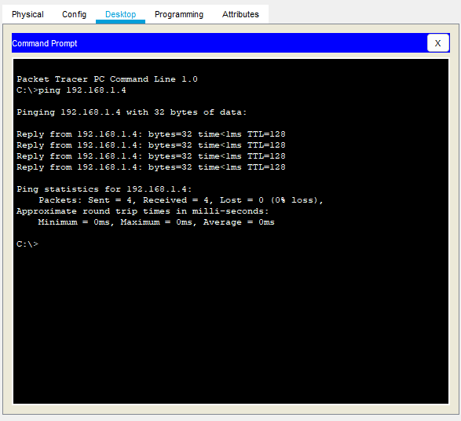

7. You can also use the closed envelope with a plus sign (**Add Simple PDU**) in the right menu of the Packet Tracer window. Click on it, then the two nodes to be checked. **This a much better way. To check it benefits, goto Simulation mode** **using Shift +S or by clicking** in the lower right corner of window.

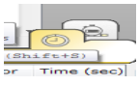

## Output:

8. Repeat the step 1-7 using Switch instead of Hub.

Using switch, we have:

## Switch Output

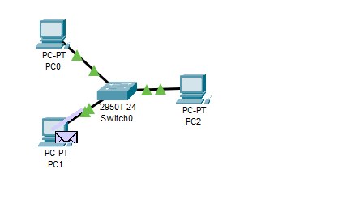

**5. Home Task**

Connect the switch and Hub and write discussion about Hub and Switch Function.

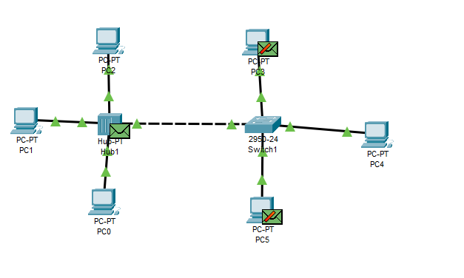

**EXPERIMENT NO 1**

**PART - 2**

**Switch Administrative Function**

# Objective

This lab exercise is designed for understanding and using basic configuration commands on a Cisco Switch interacting through Cisco IOS.

# Resources Required

* Computer
* Packet Tracer (version 5 or higher)

# Introduction

This lab introduces Cisco IOS (Internetwork Operating System) which is the proprietary CLI (command line interface) based software empowering nearly all the Cisco devices. IOS is a package of routing, switching, internetworking and telecommunications functions tightly integrated with a multitasking operating system.

The loading process in Cisco IOS is as follows:

a) Bootstrap is loaded from ROM which starts up POST (Power On Self Test).

b) Valid image file is searched from flash memory, if found is loaded into the RAM, otherwise ROMMON is loaded from ROM.

c) Valid startup-config is searched from NV-RAM, if found is loaded into the RAM as running-config, otherwise the device just starts without any previous configurations.

From this we conclude that Cisco devices have 4 types of memories present:

a) ROM

b) Flash

c) NV-RAM

d) RAM

**4. Procedure**

1. Open Packet Tracer 5 and setup a network similar to the following network. Use Cisco 2950T switch.

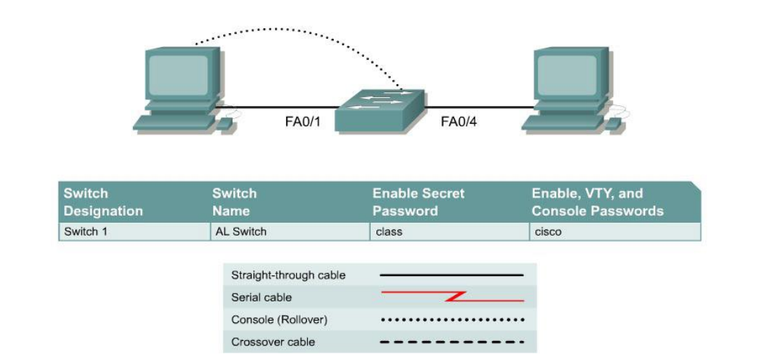

2. Double click the switch and goto CLI tab. Follow the steps below to complete the lab. You can do the same using a PC if you use a **console (one side is RS 232,** **other is RJ45—blue colored in Packet Tracer)** cable for connection between PC and Switch. Goto PC’s desktop then Terminal (equivalent of HyperTerminal), accept the default settings and login to the Switch.

**Step 1 Enter privileged mode**

a. Privileged mode gives access to all the switch commands. Many of the privileged commands configure operating parameters. Therefore, privileged access should be password-protected to prevent unauthorized use. The privileged command set includes those commands contained in user EXEC mode, as well as the **configure** command through which access to the remaining command modes is gained.

Switch>**enable**

Switch#

b. Notice the prompt changed in the configuration to reflect privileged EXEC mode.

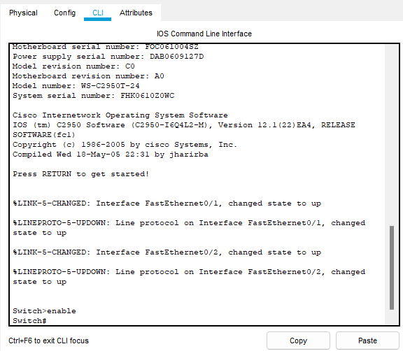

**Step 2 Examine the current switch configuration**

a. Examine the following current running configuration file:

Switch#**show running-config**

b. How many Ethernet or Fast Ethernet interfaces does the switch have?

The switch has 24 fast ethernet cables ang 2 Giga bit ether net cables.

c. What is the range of values shown for the VTY lines?

The range of the vales shown on VTY lines is form 0 to 4 and 5 to 16.

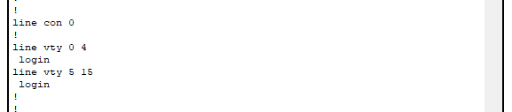

d. Examine the current contents of NVRAM as follows:

Switch#**show startup-config**

%% Non-volatile configuration memory is not present

e. Why does the switch give this response?

It says that the startup memory is not present.

**Step 3 Assign a name to the switch**

a. Enter **enable** and then the configuration mode. The configuration mode allows the management of the switch. Enter **ALSwitch**, the name this switch will be referred to in the following: Switch#**configure terminal**

Enter the configuration commands, one for each line. End by pressing **Ctrl-Z**. Switch(config)#**hostname ALSwitch**

ALSwitch(config)#**exit**

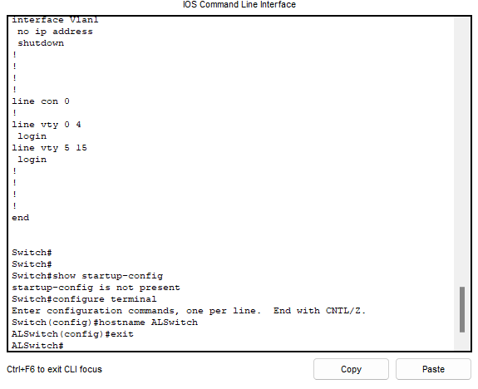

b. Notice the prompt changed in the configuration to reflect its new name. Type **exit** or press **CtrlZ** to go back into privileged mode.

**Step 4 Examine the current running configuration**

a. Examine the current configuration that follows to verify that there is no configuration except for the hostname:

ALSwitch#**show running-config**

b. Are there any passwords set on the lines?

No. It states there are no service password encryptions.

c. What does the configuration show as the hostname of this switch?

It shows the hostname switch to be ALSwitch.

**Step 5 Set the access passwords**

Enter config-line mode for the console. Set the password on this line as **cisco** for login. Configure the vty lines 0 to 15 with the password cisco as follows:

ALSwitch#**configure terminal**

Enter the configuration commands, one for each line. End by pressing **Ctrl-Z**. ALSwitch(config)#**line con 0**

ALSwitch(config-line)#**password cisco**

ALSwitch(config-line)#**login**

ALSwitch(config-line)#**line vty 0 15**

ALSwitch(config-line)#**password cisco**

ALSwitch(config-line)#**login**

ALSwitch(config-line)#**exit**

The output is as shown:

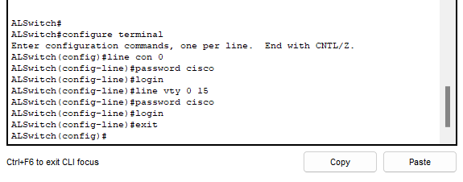

**Step 6 Set the command mode passwords**

a. Set the **enable password** to cisco and the **enable secret password** to **class** as follows:

ALSwitch(config)#**enable password cisco**

ALSwitch(config)#**enable secret class**

b. Which password takes precedence, the enable password or enable secret password?

Enable secret password takes precedence than enables password as shown:

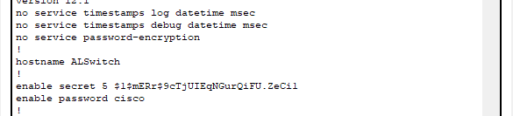

**Step 7 Save the configuration**

a. The basic configuration of the switch has just been completed. Back up the running configuration file to NVRAM as follows:

**Note:** This will ensure that the changes made will not be lost if the system is rebooted or loses power.

ALSwitch#**copy running-config startup-config**

Destination filename [startup-config]?[**Enter**] Building configuration... [OK]

ALSwitch#

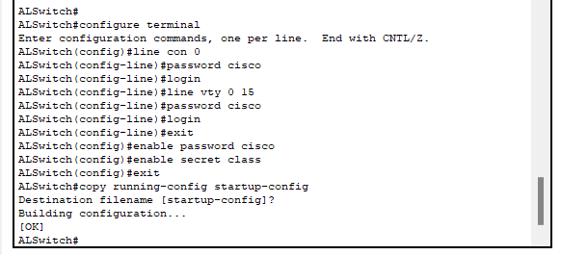

**Step 8 Examine the startup configuration file**

a. To see the configuration that is stored in NVRAM, type **show startup-config** from the privileged EXEC (enable mode)

ALSwitch#**show startup-config**

b. What is displayed?

c. Are all the changes that were entered recorded in the file?

Yes all the changes that we entered were recorded in the file.

**Step 9 Configure the hosts attached to the switch**

Configure the hosts to use the same IP subnet for the address, mask.

**Step 10 Verify connectivity**

a. To verify that hosts and switch are correctly configured, ping the switch IP address from the hosts.

b. Were the pings successful?

Yes the ping was successful to the hosts.

c. If the answer is no, troubleshoot the hosts and switch configurations.

**Step 11 Record the MAC addresses of the host**

a. Determine and record the layer 2 addresses of the PC network interface cards. Check by using command **ipconfig /all** in command prompt of the Packet Tracer PC (in Desktop tab).

b. PC0:

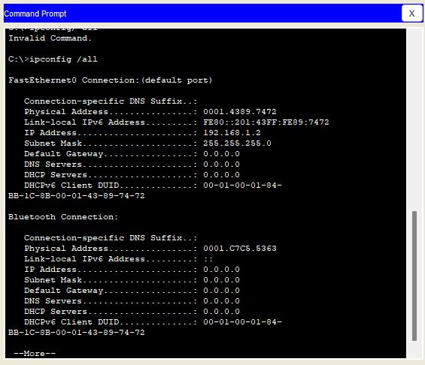

c.PC1:

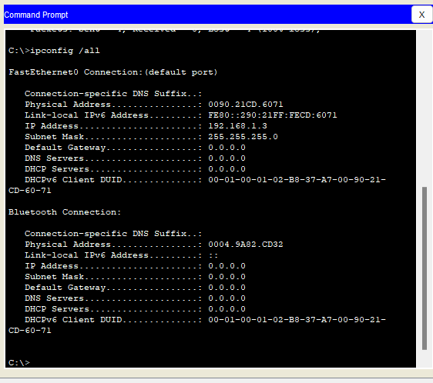  
**Step 12 Determine the MAC addresses that the switch has learned**

a. To determine the what MAC addresses the switch has learned use the **show mac-address-table** command as follows at the privileged EXEC mode prompt:

ALSwitch#**show mac-address-table**

b. How many dynamic addresses are there:

There is 1 dynamic address.

c. How many total MAC addresses are there:

There is 1 MAC address.

d. How many addresses have been user defined:

No addresses have been user defined

e. Do the MAC addresses match the host MAC addresses?

Yes this MAC addresses Matches the MAC address of the user.(Host)

**Step 13 Determine the show MAC table options**

a. To determine the options the **show mac-address-table** command has use the **?** option as follows:

ALSwitch#**show mac-address-table ?**

b. How many options are available for the **show mac-address-table** command?

The command hsows that 3 mac address tables were present.

c. Show only the mac-address-tables that were learned dynamically.

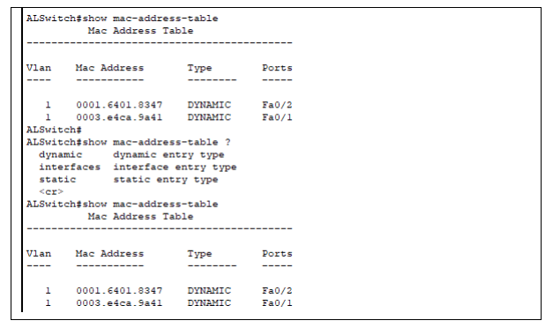

d. How many are there?

There are 2.

**Step 14 Clear the MAC address table**

To remove the existing MAC addresses use the **clear mac-address-table** command from the privileged EXEC mode prompt as follows:

ALSwitch#**clear mac-address-table dynamic**

**Step 15 Verify the results**

1. Verify that the **mac-address-table** was cleared as follows:

ALSwitch#**show mac-address-table**

1. How many total MAC addresses are there now?

There are 2 Mac addresses present now.

c. Why are there so many?

d. How many dynamic addresses are there?

There are no dynamic address present now because we cleared the tables.  
**Step 16 Determine the clear MAC table options**

a. To determine the options available use the command **clear mac-address-table ?** at the privileged EXEC mode prompt as follows: ALSwitch#**clear mac-address-table ?**

b. How many options are there?

There are 2 options available

**Step 17 Examine the MAC table again**

a. Look at the MAC address table again using the **show mac-address-table** command at the privileged EXEC mode prompt as follows:

ALSwitch#**show mac-address-table**

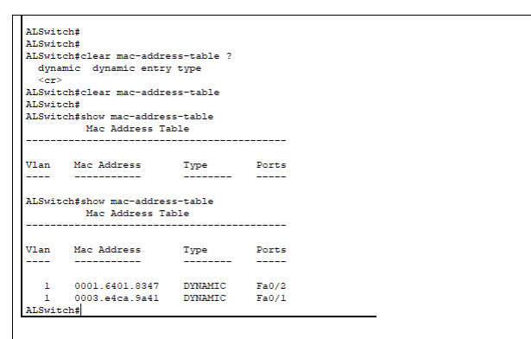

b. How many dynamic addresses are there?

There are no mac address tables present again.

**Step 18 Exit the switch**

Leave the switch welcome screen by typing **exit** as follows:

ALSwitch#**exit**

# Conclusion

During the lab session, we were introduced to the Cisco Packet Tracer software and gained knowledge on how to connect hubs and switches to PCs. Additionally, we learned about the features and operations of hubs and switches such as packet transmission between computers, the protocols they follow, and their broadcast and collision domains. Overall, the lab provided us with a comprehensive understanding of network infrastructure and how various components work together to facilitate communication between devices.

**5. Home Task**

Connect the five PCs to Switch and repeat the lab procedure

1. Set the banner on switch

2. Set the password NameRollNo

3. Set secret password YourLastName

4. Switch Name AU_BEE_ClassName